Day -11 ROBO Project
NoSQL (MongoDB - DocumentDB
- data is un sctructured
- useful when huge amounts of data
- data is stored as documents
- generally used for product catalouges, Real-time analytic, etc but not for transactions
Redis:
- in memory database
- Data is in HDD, RAM takes data from HDD to deliver to Processor
- Key-value database
- Apps looks data in cache first, if it is not available in cache then in database
Producer: Who produce the request
Consumer: Who receives the request
Asynchronous:
- ActiveMQ, IBM MQ, RabiitMQ, Kafka, etc
- Request and forget – main, whatsapp etc..
- No waiting, good user experience
- Scalability
- Reliability
- Loose coupling
  - Tight coupling -> with in our system
- Queue management
Synchronous:
- Request and wait - http
Publisher/Subscriber -> one to many
Queue -> 1 to 1
Publisher -> who is sending message
Subscriber -> who is following

First, the Core Idea (One Line Each)
Synchronous means:
👉 “Do one thing, wait until it finishes, then do the next.”
Asynchronous means:
👉 “Start something, don’t wait, do other work, and handle the result later.”
That’s it.

Ex:

Synchronous – How It Works in Real Life
Imagine you go to a restaurant and order food. You stand at the counter, place the order, and wait there doing nothing until your food is prepared and handed to you. Only after that can you leave or do something else. This is synchronous behavior. Your life is blocked until the task completes.
In computing terms, synchronous systems block execution. When a task starts, the system waits for the response before moving forward. Nothing else progresses in between.
- scp bigfile.zip user@server:/data/
- Your terminal is now blocked.
You cannot type anything meaningful until the file transfer finishes.
This is synchronous:
- Start task
- Wait
- Get result
- Continue

DevOps Real-Time Synchronous Example
In a CI/CD pipeline, if one stage must finish before the next starts, that is synchronous.
Example:
- Build application
- Wait until build finishes
- Run tests
- Wait until tests finish
- Deploy
If build fails, everything stops.
This strict order is synchronous execution.
Synchronous is chosen when:
- Order matters
- Result is immediately required
- Failure must stop the flow
---------------
- Asynchronous – How It Works in Real Life
Now imagine a restaurant with a token system. You place the order, they give you a token, and you are free to sit, talk, or do other things. When the food is ready, they call your token number. You didn’t wait doing nothing—you continued your life.
This is asynchronous behavior.
The task runs in the background, and you are notified when it finishes.
- DevOps Real-Time Asynchronous Example
Think about log processing.
Your application writes logs continuously.
A separate system (like ELK or CloudWatch) collects logs asynchronously.
The application does NOT wait for logs to be processed.
If it did, your app would be slow or unusable.
Asynchronous is used when:
- Speed matters
- Tasks are independent
- Waiting would waste resources

Project starts here steps:
- Install 3 EC2 instances.
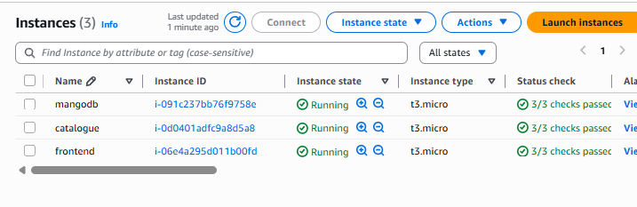
- # sudo su –

- Install Mango DB:
  - Installation Process : https://www.mongodb.com/docs/v7.0/tutorial/install-mongodb-on-red-hat/

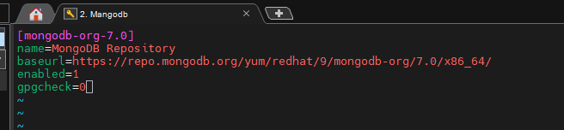
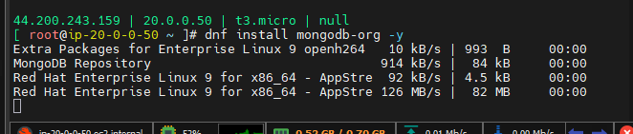
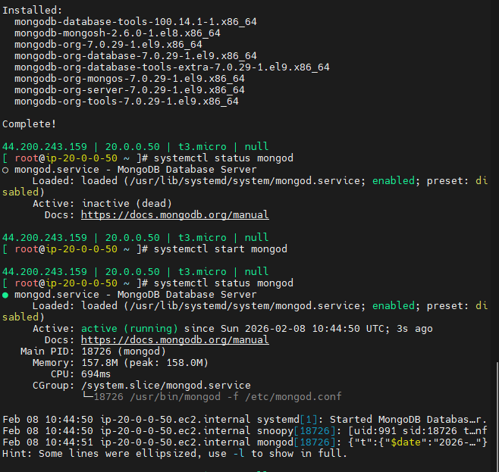

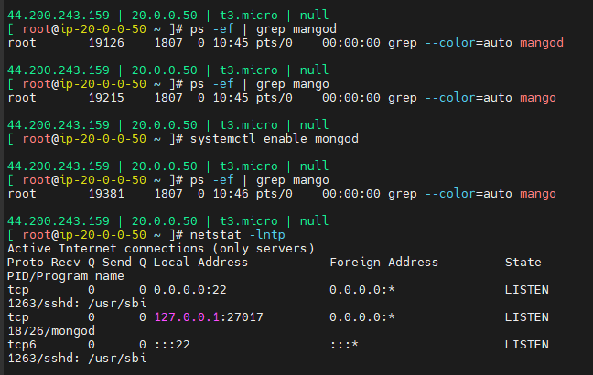
- By default databases are not accepted outside connections. In the above screen (127.0.0.1:27017) is allowing only local machine.
- 27017 is a Mongodb port
- To allow everyone we need to open the below file to edit.
- #vim /etc/mongod.conf
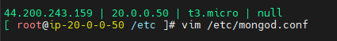
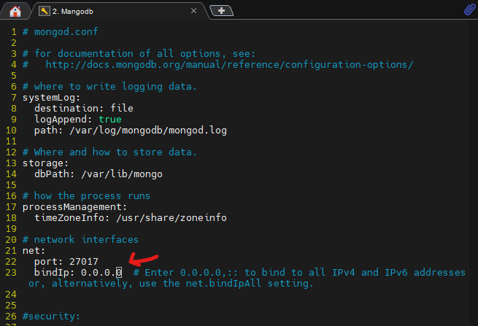

- 0.0.0.0 -> Everyone
- Restart the service mongod
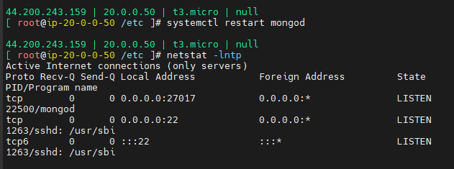

- Create Catalogue:
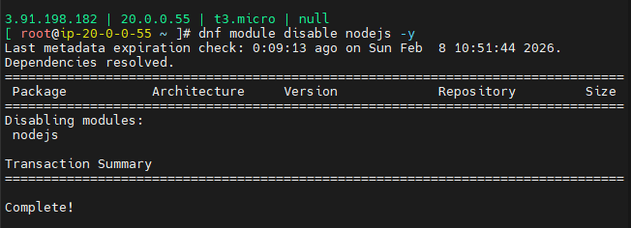
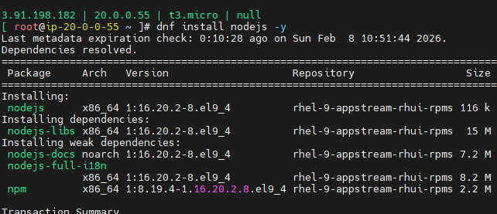
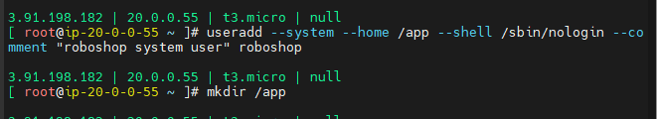
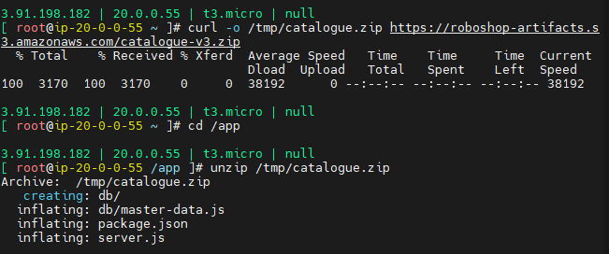

- #cd /app
- #npm install
- Go to route53 and create a record
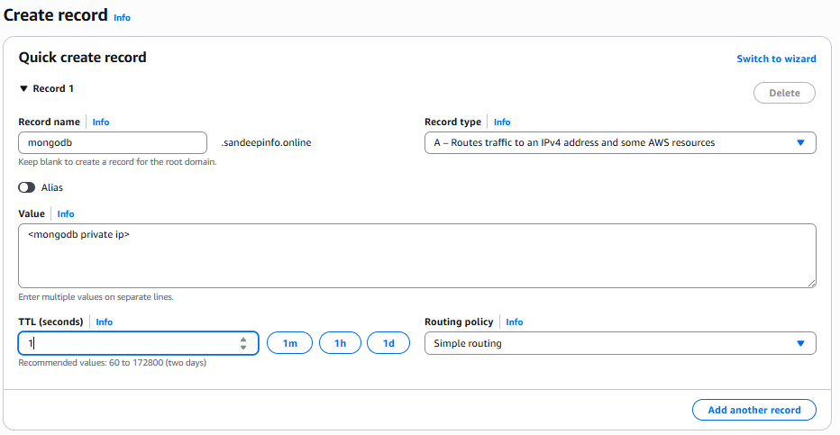
- # vim /etc/systemd/system/catalogue.service
- Add the dns name in the file
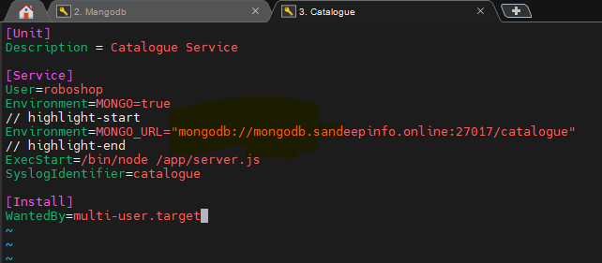
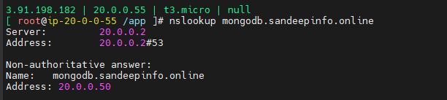
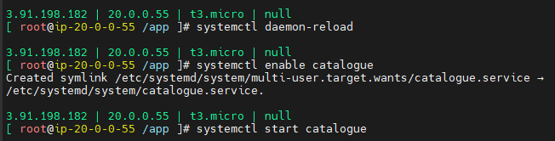

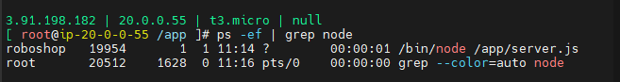
- #curl http://localhost:8080/health
- Health the connection heath. If it shows “mongo” false” then it is unhealthy and you need to allow the mongo db port in security group.
